TASK 2

**Step 1: Create Target Groups**

1. Go to EC2 → **Target Groups** → Create Target Group
2. Choose:
   * Target type: **Instances**
   * Protocol: **HTTP**
   * Port: **8080** (for Jenkins)
3. Name the Target Group
4. Register your EC2 instance with it
5. Health check path:**/**

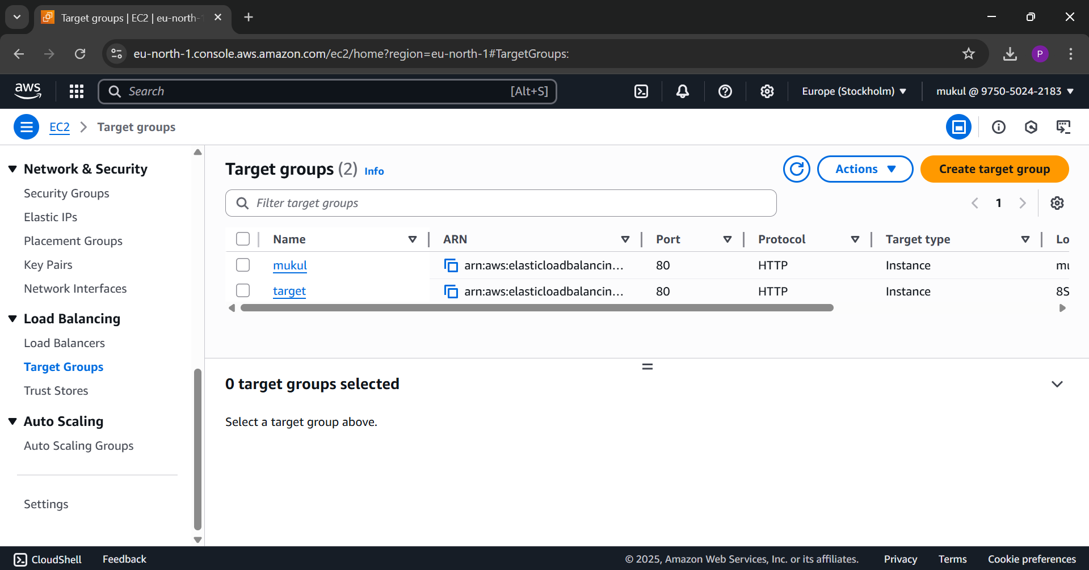

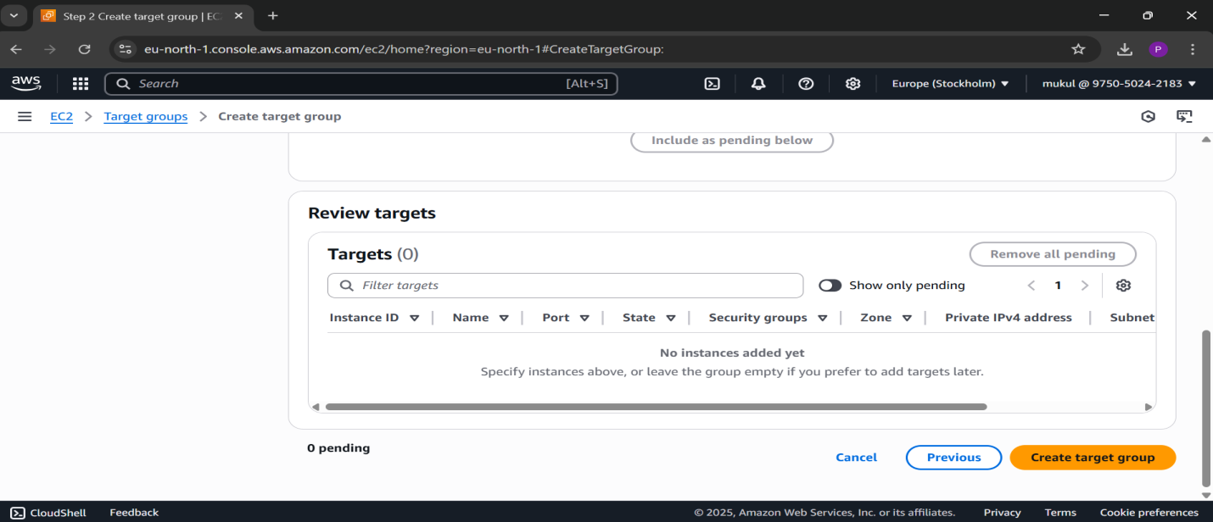

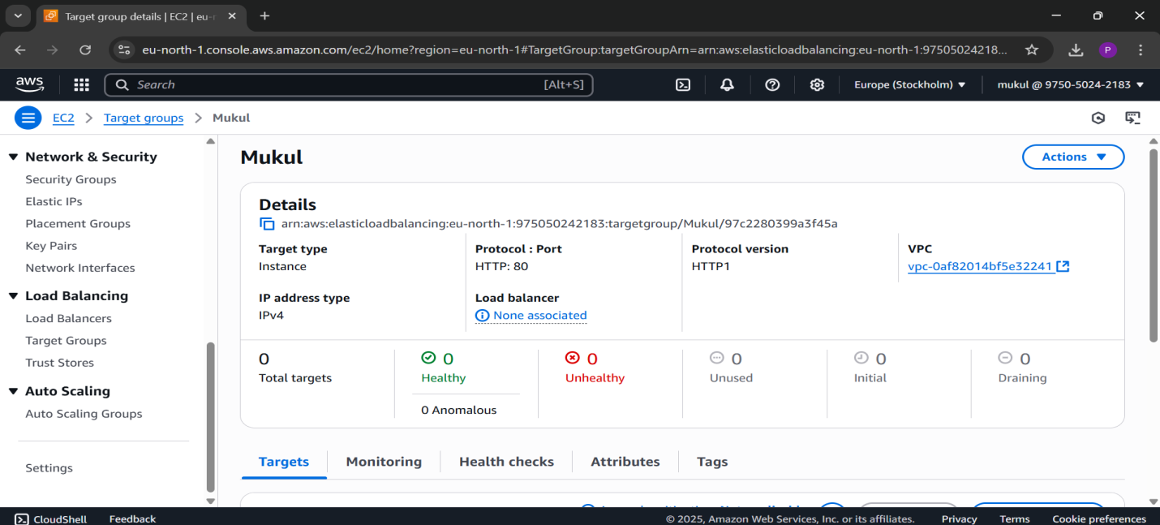

**Step 2: Create an Application Load Balancer**

1. Go to EC2 → **Load Balancers → Create Load Balancer**
2. Choose **Application Load Balancer**
3. Name: 8-SEM-Workshop
4. Scheme: **Internet-facing**
5. Listener: HTTP on **Port 80**
6. Select **2 subnets** from different Availability Zones
7. Security Group: Allow **Port 80**

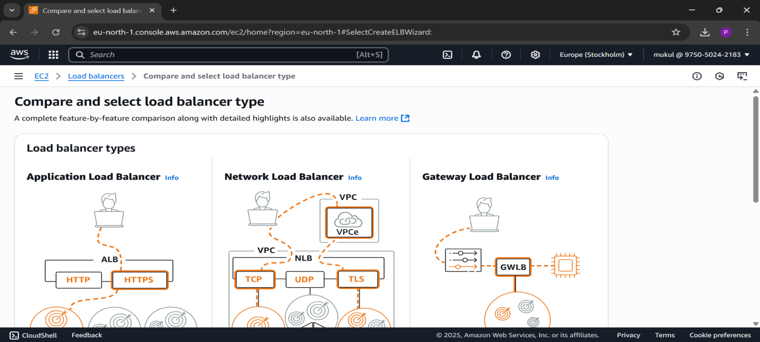

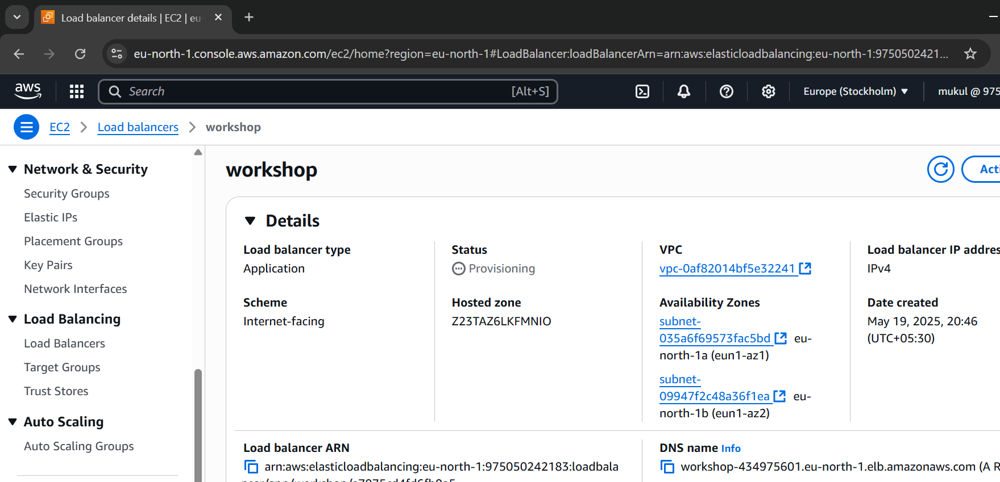

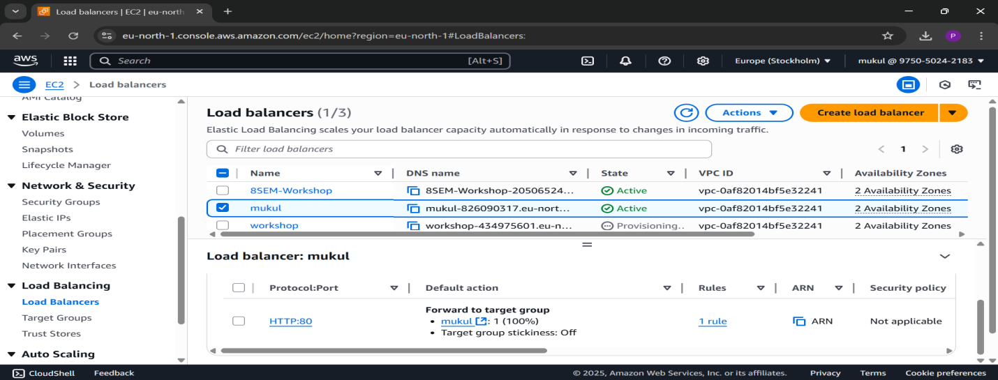

**Step 3: Set Listener Rules for Path-Based Routing**

1. Go to EC2 → **Load Balancers → Listeners**
2. Click **View/Edit Rules** on Listener: HTTP:80
3. Delete default rule or leave it
4. Add new rules:

**Example 1:**

* Condition: Path is /jenkins*
* Action: Forward to jenkins-tg

1. Save the rules

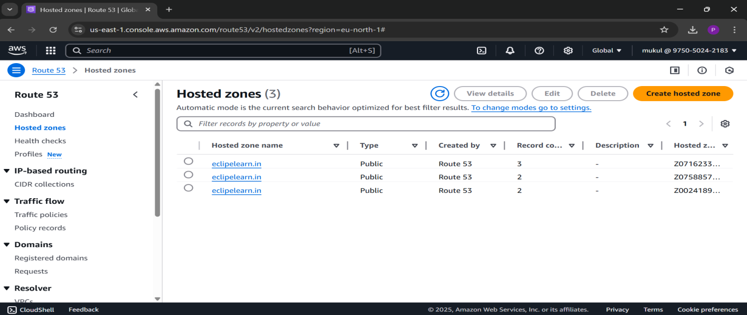

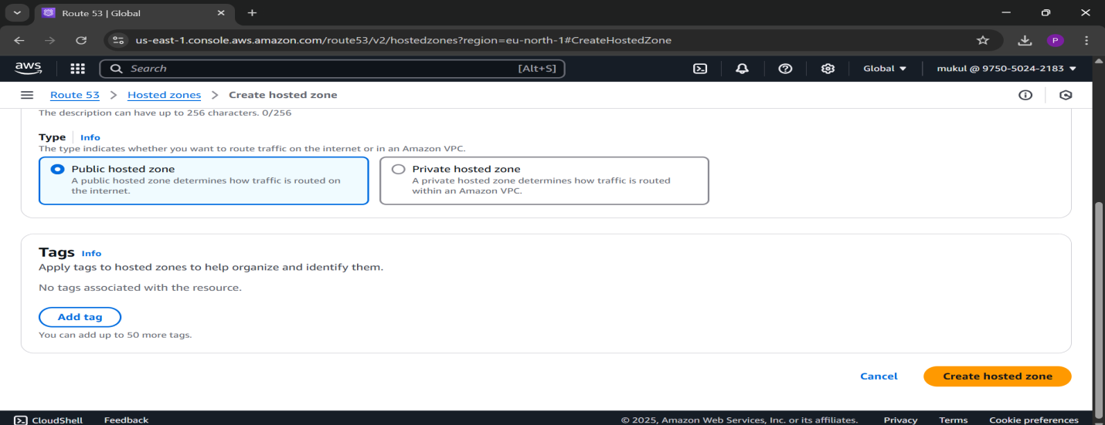

**Step 5:Request SSL Certificate from AWS Certificate Manager (ACM)**

1. Go to [**AWS Certificate Manager**](https://console.aws.amazon.com/acm/home)
2. Click **“Request a certificate”**
3. Choose **“Request a public certificate”** → Click **Next**
4. **Add the domain names**:
   * ecliplearn.in
   * www.ecliplearn.in *(optional, but recommended)*
5. Click **Next**
6. **Validation method**: Choose **DNS validation (Recommended)** → Click **Next**
7. Click **Confirm and request**

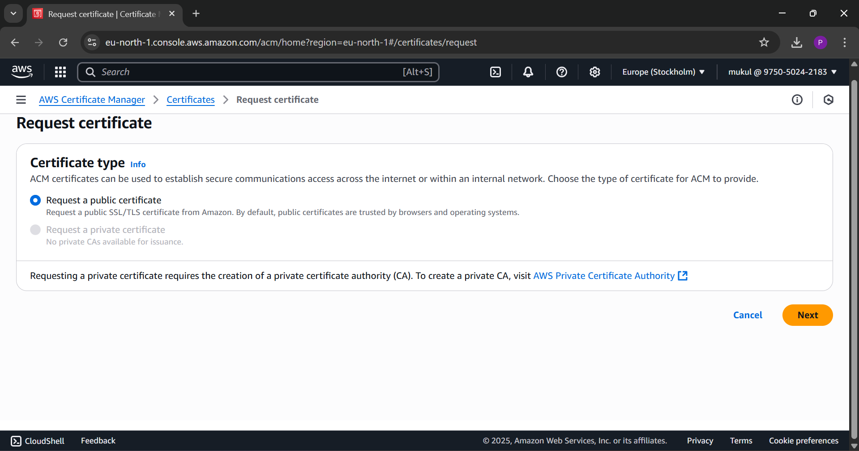

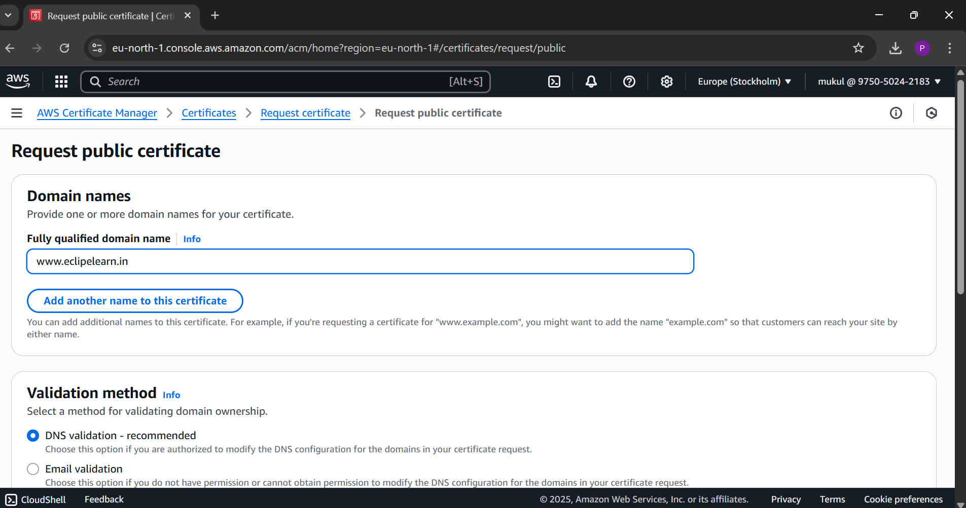

**Step 6: Validate the Certificate Using DNS (Route 53)**

1. After submitting the certificate request, ACM will show a **CNAME record**
2. Go to **Route 53 → Hosted Zones → ecliplearn.in**
3. Click **Create record**
4. Paste the CNAME record provided by ACM:
   * **Name**: As given by ACM
   * **Value**: As given by ACM
   * **Record type**: CNAME
5. Save the record

⏳ Wait a few minutes. The certificate status in ACM will become **“Issued”** once validated.

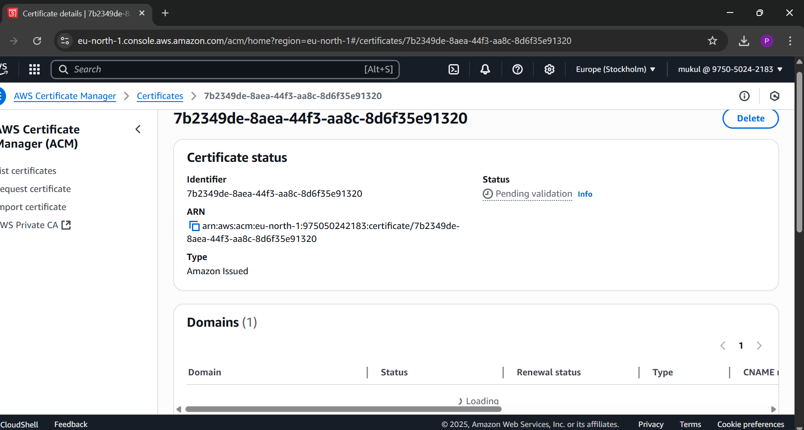

**Step 7:Add HTTPS Listener (Port 443) in ALB**

1. Go to **EC2 → Load Balancers**
2. Select your **Application Load Balancer**
3. Under the **Listeners** tab → Click **“Add listener”**
4. **Protocol**: HTTPS
5. **Port**: 443
6. **Default action**: Forward to your Jenkins **Target Group**
7. **SSL Certificate**:
   * Choose **“From ACM”**
   * Select the certificate for ecliplearn.in
8. Save the listener

